CS 340 Week 7 README

About the Project/Project Title
This program builds an interactive dashboard for Grazio Salvare, a company that specializes in rescue animal discovery and training. The dashboard connects to a MongoDB database of the Austin Animal Center (AAC) records and provides a method to filter and explore the animals to meet specific adoption and/or training criteria.

The program successfully demonstrates how CRUD operations, Dash, and MongoDB can be integrated into a working data application.

This application follows the Model-View-Controller (MVC) design pattern:
- MongoDB model that serves as the data source
  - As a document-orientated NoSQL database, MongoDB allows flexible storage of JSON-like records
  - Integrates easily with Python through the PyMongo driver
- Dash framework as the View/Controller that manages the layout, callbacks, and under interaction.
  - Combines Flask (backends), React.js (grontend), and Pltly (graphs) into a Python-friendly package

Motivation
The motivation to use CRUD lies in its ability to efficiently manage and manipulate data in a NoSQL database. MongoDB’s document-orientated model allows for flexible data storage and scalability. PyMongo simplifies the process of performing CRUD operations, enabling developers to create, read, update, and delete documents seamlessly. This module provides a reusable Python interface for MongoDB that:
- Encapsulates database logic inside a Python class
- Enforces consistent, authenticated database access
- Simplifies CRUD operations for NoSQL data

Features
- MongoDB Integration
  - Reads the AAC records from a MongoDB collection using the AnimalShelter class
  - Drops the _id field so data can be safely displayed in Dash
- Interactive filtering
  - Radio buttons to filter for specific animal use cases:
    - All
    - Water Rescue
    - Mountain and Wilderness Rescue
    - Disaster and Tracking Rescue
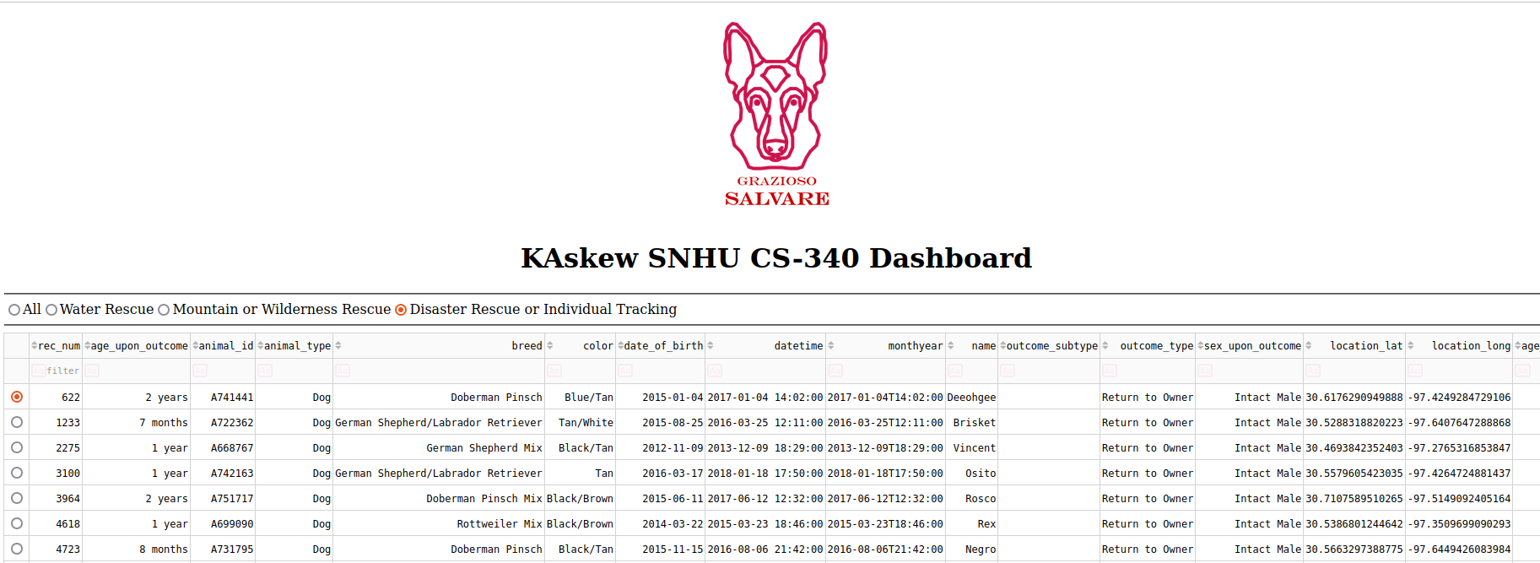

- Interactive Data Table
  - Displays animal records from MongoDB
  - Supports filtering, sorting, pagination (the process of dividing a document into discrete pages), and single-row selection
  - Highlights selected columns with a highlighted background color
- Visualizations
  - Pie Chart: Shows breed distribution for the currently filtered animals
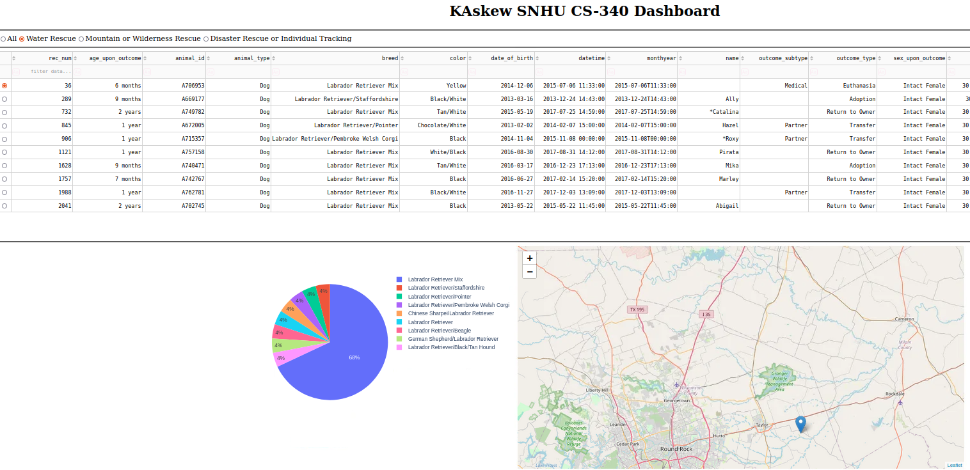
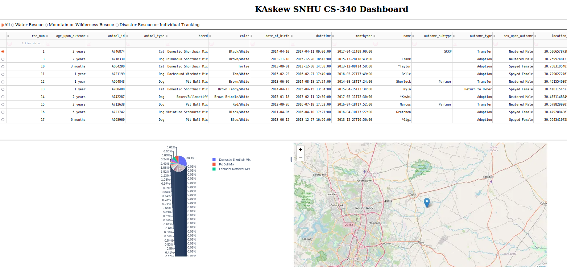
  - Interactive Geolocation Map: Displays the selected animal’s location in Austin, TX

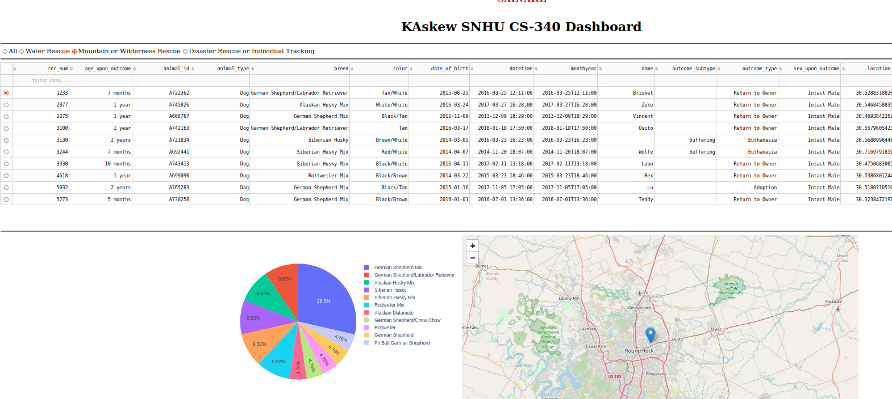
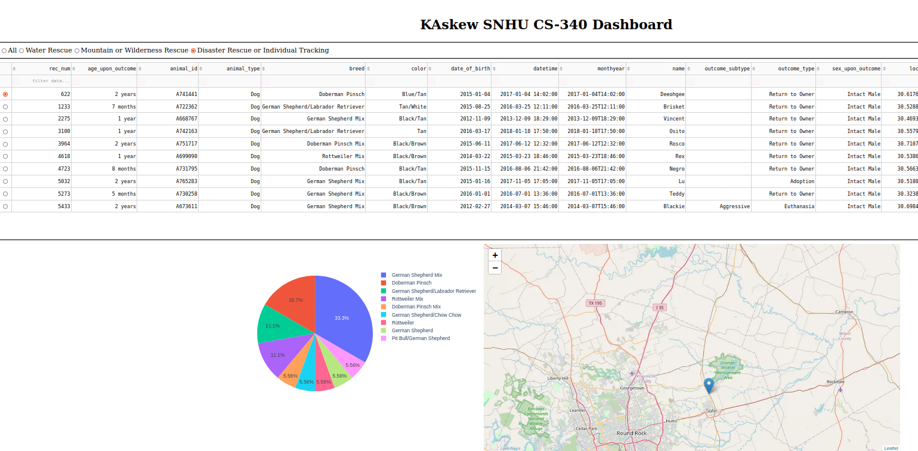

Tools chosen for this module
The following tools need to be installed:
- Python 3.9+
- Jupyter Notebook or JupyterLab for interactive testing and demonstration
- MongoDB server running locally with AAC dataset loaded
- Required Python packages:
  - Dash
  - Plotly
  - Pandas
  - Matplotlib
  - pypmongo
- Created a user account in mongo shell to ensure user authentication to the database collection

Usage
If this project needs to be recreated due to critical failure in the code or database issues, follow these steps:
- Install required components discussed in Tools chosen for this module
- Use or create an account in MongoDB
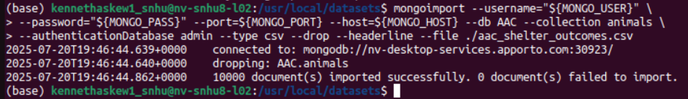
- Specify the user roles and rights needed
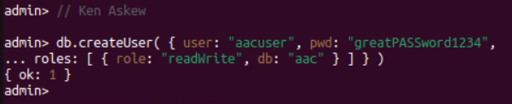
- Re-add the CRUD/ AnimalShelter.py class and middleware-dashboard driver to the host server
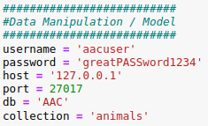
- Add the Dash components and their call backs
  - Data table code example
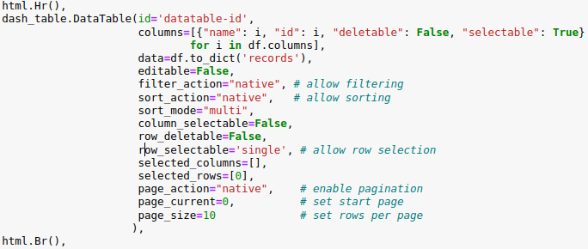
  - Html div holding widgets example
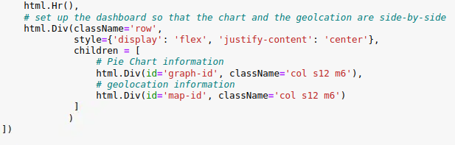
  - Radio buttons acting as filter examples
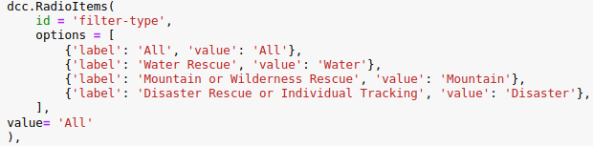
  - Html anchor for logo and link to homepage example
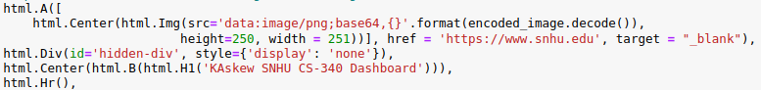
- Update and regular expressions used for filtering if they have changed
- Start MongoDB
- Start the Python middleware-dashboard driver

To use this CRUD project, the following methods are supplied:
- Constructor
  - The constructor will take care of initializing the MongoDB client, connecting to the database.
- Create method
  - This method will create a record with the data in the argument. If the record is inserted correctly, a confirmation message will print claiming insert is successful.
  - Create the animal object and initialize the MongoDB server through the constructor.
    - animal.createRecord(test_data)
    - Example of record to be inserted:
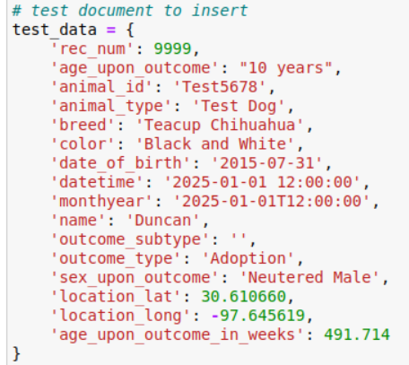
- Read method
  - This method will read an object passed in through the parameter using an attribute. The read will print all attribute information with the document.
    - animal.readRecord({‘animal_id’: ‘Test5678’})
- Update method
  - This method will find a record within the database collection that matches the query criteria and update whichever information the user chooses
    - animal.updateRecord({‘animal_id’: ‘Test5678’}, {‘name’: ‘Duncan’})
- Delete method
  - This method will find a record matching the query criteria and delete it from the document
    - Animal.deleteRecord({‘animal_id’: ‘Test5678’})

- Below is an example of the CRUD functionality:
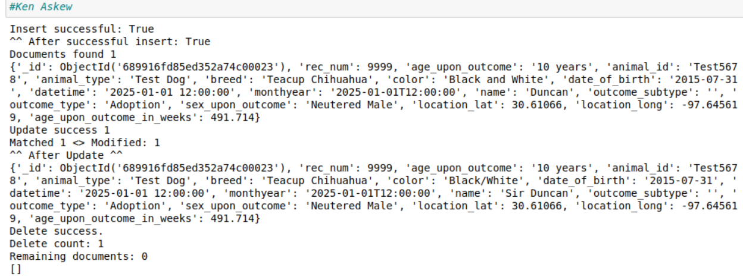

Issues and Challenges
- Syntax Errors
  - This program is very strict when it comes to spacing and proper closing of blocks. I ensured proper syntax by checking my code multiple times to avoid these errors that can cause the program to malfunction or behave improperly as well as read the error reports provided with the Jupyter IDE and the MongoDB NoSQL database management system
- Pie-Chart labels overlap with many categories
  - Aggregated results into the top breeds as well as “Other” for superior readability

Contact
Kenneth Askew, kenneth.askew1@snhu.edu

